**DAILY ONLINE ACTIVITIES SUMMARY**

|  |  |  |  |  |  |  |  |  |
| --- | --- | --- | --- | --- | --- | --- | --- | --- |
| **Date:** | **13 /6/2020** | | | | **Name:** | **Harshitha M** | | |
| **Sem & Sec** | **8th Sem** | | | | **USN:** | **4AL16CS038** | | |
| **Course** | **IOT** | | | | | | | |
| **Max Marks** | **29** | | **Score** | | | | | **30** |
| **Certification Course Summary** | | | | | | | | |
| **Course** | **Introduction to cyber security** | | | | | | | |
| **Certificate Provider** | | **Great Learning** | | **Duration** | | | **5hrs** | |
| **Coding Challenges** | | | | | | | | |
| **Problem Statement:** Python Program to Display Calendar | | | | | | | | |
| **Status:Completed** | | | | | | | | |
| **Uploaded the report in Github** | | | | **yes** | | | | |
| **If yes Repository name** | | | | **Harshitha-M** | | | | |
| **Uploaded the report in slack** | | | | **yes** | | | | |

Online Test Details: (Attach the snapshot and briefly write the report for the same)

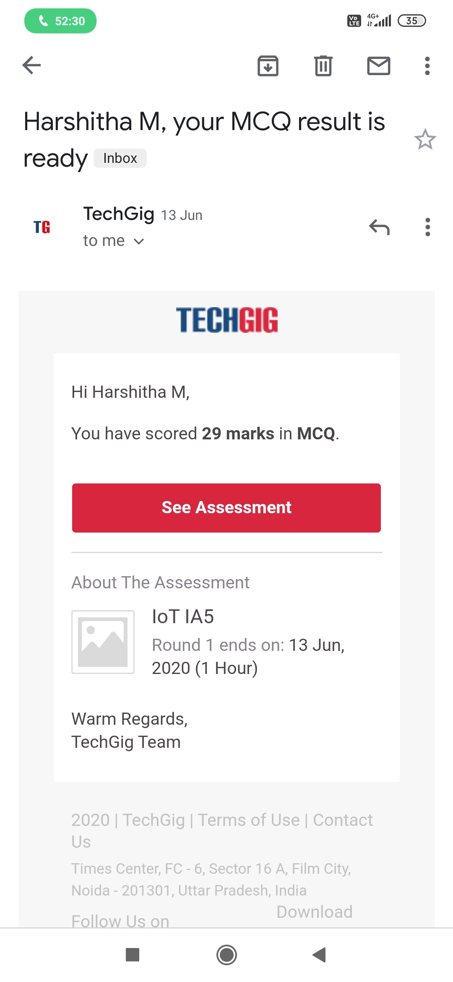

Certification Course Details: (Attach the snapshot and briefly write the report for the same)

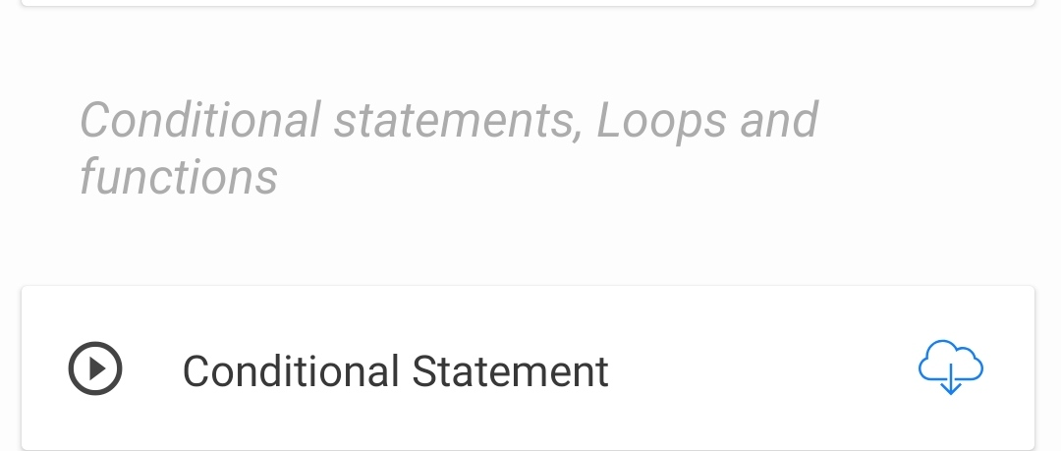

Coding Challenges Details: (Attach the snapshot and briefly write the report for the same)

PROGRAM1

import calendar

yy = 2014 # year

mm = 11 # month

# To take month and year input from the user

# yy = int(input("Enter year: "))

# mm = int(input("Enter month: "))

# display the calendar

print(calendar.month(yy, mm))